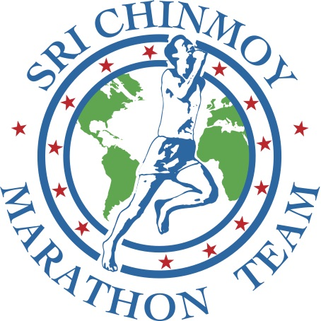
RESULTS for Self-Transcendence La Jolla Swim & Run
May 20, 2018

Thank you to all who participated in the Self-Transcendence La Jolla Swim & Run on May 20, 2018!

CLICK HERE TO SEE RESULTS

